Les Salutations- Hellos and Goodbyes

Le tableau ci-dessous montre une liste des salutations qu’on peut utiliser quand on rencontre quelqu’un et quand on quitte quelqu’un. The table below shows a list of greetings that we can use when we meet someone and when we leave someone.

Hello!: The Openers
Formel vs. Familier (Formal vs. Informal/casual) | Français | Anglais
Formel (Formal) | Bonjour!  (bohn.joor) | Good morning/hello!
 | Bon après-midi!  (bohn ah.preh.mee.dee) | Good afternoon!
 | Bonsoir!  (bohn.swahr) | Good evening!
 | Bonne nuit!  (bohn nwee) | Good night!
Familier (Informal /casual) | Salut!  (sah.lew) | Hi!
Goodbye!: The Closers
Formel vs. Familier (Formal vs. Informal/casual) | Français | Anglais
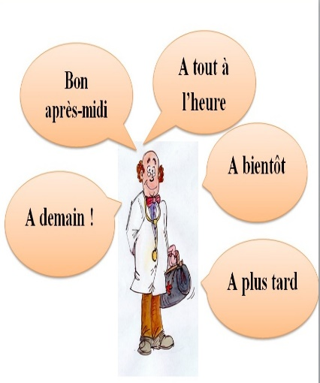  Formel (Formal) | Au revoir!  (o ruh.vwahr) | Goodbye!
 | Adieu!  (ah.dyuh) | Farewell!
 | Bonne journée!  (bohn joor.neh) | Have a good/nice day!
 | Bonne soirée  (bohn swah.ray) | Have a good evening!
 | À demain!  (ah duh.mahn) | See you tomorrow!
 | À bientôt!  (ah byahn.toh) | See you soon!
 | À tout de suite!  (ah too deu sweet) | See you in a second/ See you in a little while!
 | À tout à l’heure!  (ah too tah leur) | See you soon/See you in a while!
 | À plus tard!  (ah plew tahr) | See you later!
Familier (Informal/casual) | À plus  (ah plews) | Later/Laters!
 | À la prochaine!  (ah lah pro.shehn) | Until next time!

